## **S&P500 - ESG Data Analytics Report**

### **Introduction**

This report provides an in-depth analysis of the relationship between ESG (Environmental, Social, and Governance) scores and financial performance metrics of companies listed in the S&P 500. It focuses on understanding the correlations and significant differences across various sectors, leveraging hypothesis testing and visualization techniques.

### **Data Overview**

* **S&P 500 Constituents Financials**: Financial metrics of S&P 500 companies.
* **S&P 500 ESG Risk Ratings**: ESG risk ratings for S&P 500 companies.

### **Objectives**

1. **Correlation Analysis**: Examine the correlation between ESG scores and financial metrics.
2. **Hypothesis Testing**: Test hypotheses regarding the impact of ESG scores on financial performance.
3. **Sector Analysis**: Analyze the average earnings per share (EPS) for companies with high and low ESG scores across different sectors.

### 

### **Data Cleaning and Preparation**

The data cleaning process involved handling missing values, renaming columns for consistency, and merging the datasets on the common identifier (company symbol). Below is the correlation matrix derived from the cleaned data.

#### **Figure 1: Correlation Matrix of Financial Metrics and ESG Scores**

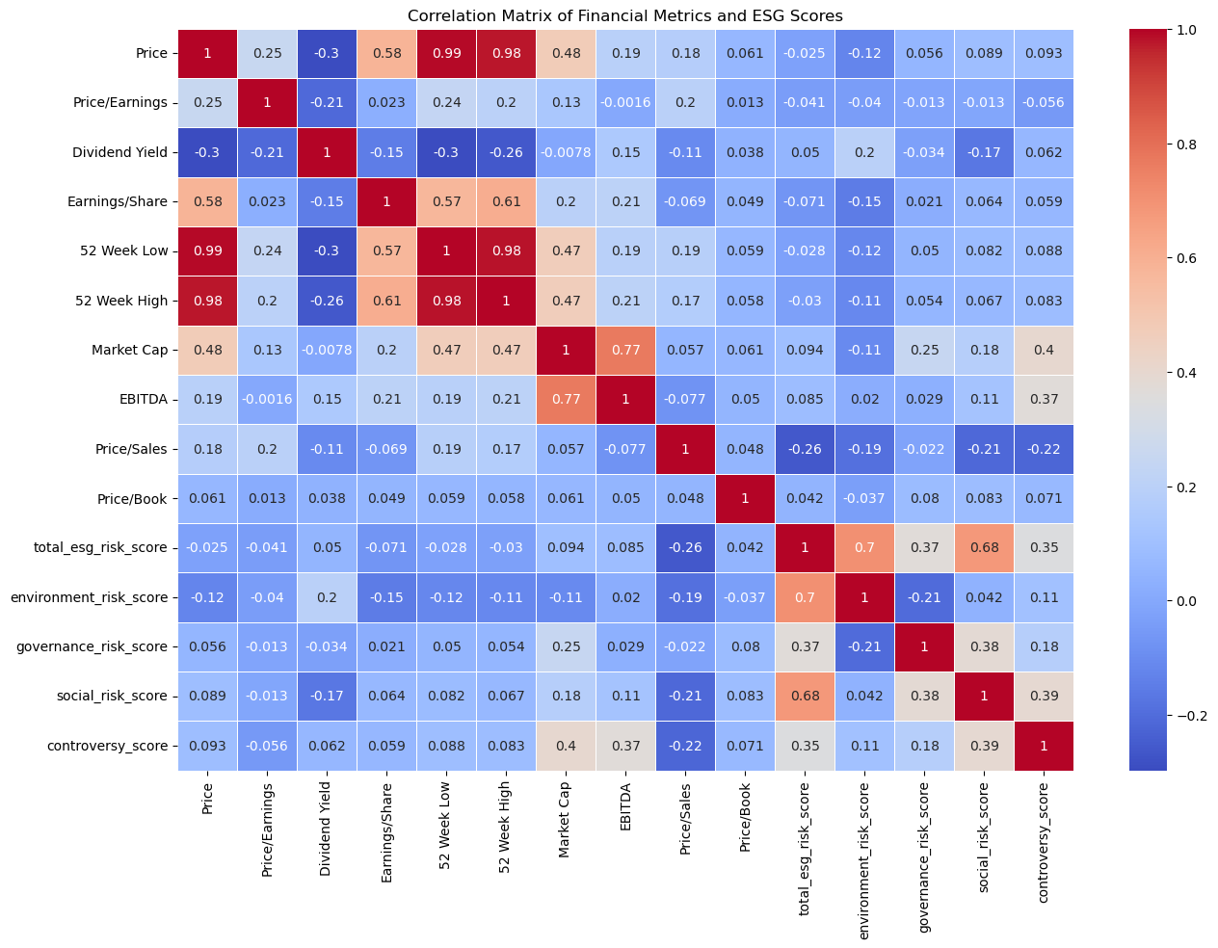

### **Hypothesis Testing**

#### **Question 1: Is there a significant correlation between Market Cap and Total ESG Risk Score?**

* **Null Hypothesis (H0)**: There is no significant correlation between Market Cap and Total ESG Risk Score.
* **Test Used**: Pearson Correlation

#### **Figure 2: Correlation between Market Cap and Total ESG Risk Score**

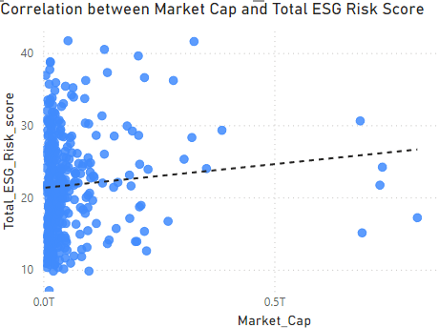

* **Results**:
  + Correlation coefficient: 0.094
  + p-value: 0.067
* **Conclusion**: Since the p-value is greater than 0.05, we fail to reject the null hypothesis. There is no significant correlation between Market Cap and Total ESG Risk Score.

#### **Question 2: Does the Environment Risk Score have a significant impact on Earnings/Share?**

* **Null Hypothesis (H0)**: Environment Risk Score has no significant impact on Earnings/Share.
* **Test Used**: Linear Regression
* **Results**:
  + Coefficient for Environment Risk Score: -0.148
  + p-value: 0.003
* **Conclusion**: Since the p-value is less than 0.05, we reject the null hypothesis. The Environment Risk Score has a significant impact on Earnings/Share.

#### **Figure 3: Impact of Environment Risk Score on Earnings/Share**

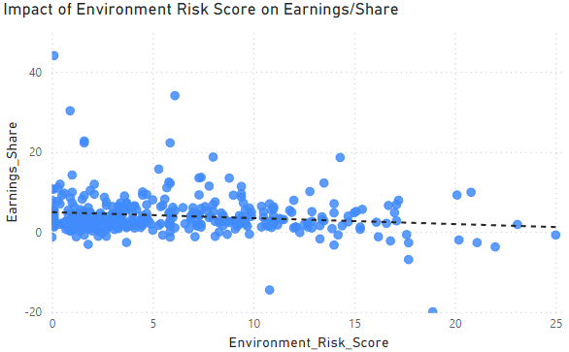

#### **Question 3: Are the mean Governance Risk Scores different across different sectors?**

* **Null Hypothesis (H0)**: The mean Governance Risk Scores are the same across all sectors.
* **Test Used**: ANOVA
* **Results**:
  + F-statistic: 32.52
  + p-value: 6.27e-45
* **Conclusion**: Since the p-value is less than 0.05, we reject the null hypothesis. The mean Governance Risk Scores are different across different sectors.

#### **Figure 4: Mean Governance Risk Scores Across Sectors**

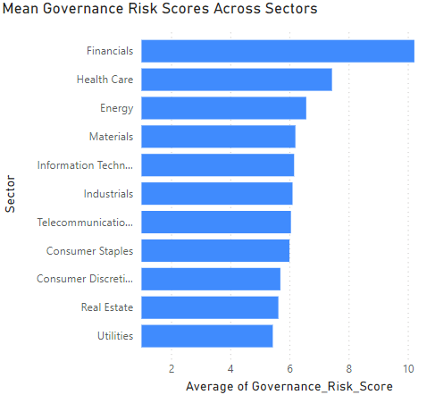

#### **Question 4: Is there a significant difference in Dividend Yield between companies with high and low ESG Risk Percentiles?**

* **Null Hypothesis (H0)**: There is no significant difference in Dividend Yield between companies with high and low ESG Risk Percentiles.
* **Test Used**: T-test
* **Results**:
  + t-statistic: 2.39
  + p-value: 0.017
* **Conclusion**: Since the p-value is less than 0.05, we reject the null hypothesis. There is a significant difference in Dividend Yield between companies with high and low ESG Risk Percentiles.

#### **Figure 5: Dividend Yield by ESG Risk Percentiles**

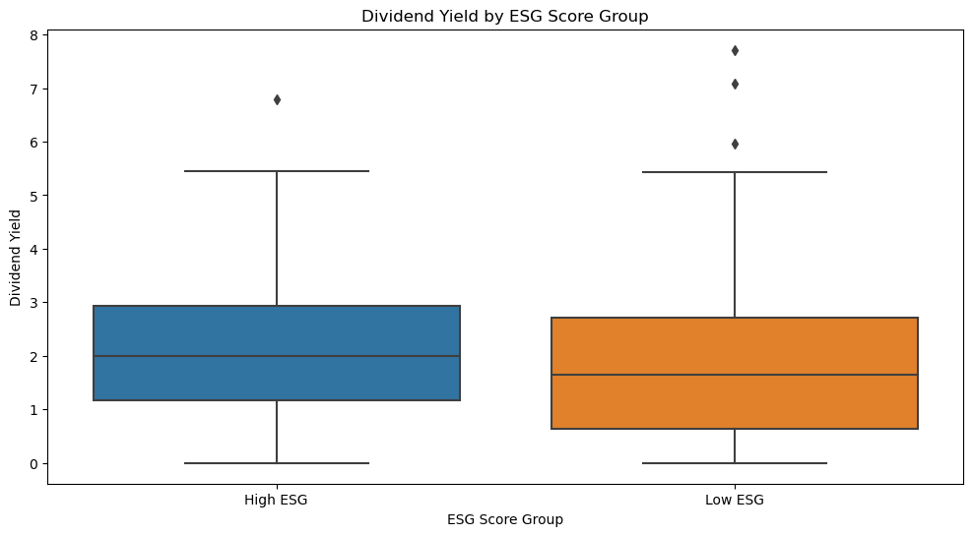

### **Sector Analysis**

The analysis compared the average Earnings per Share (EPS) for companies with high and low ESG scores across various sectors.

#### **Figure 6: Average Earnings/Share for High and Low ESG Scores by Sector**

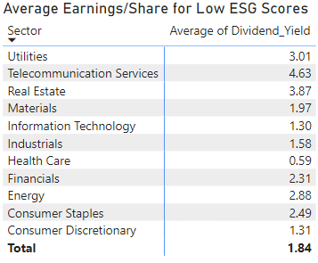

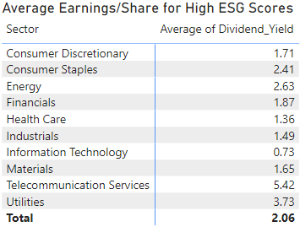

### **Key Findings**

1. **No Significant Correlation**: There is no significant correlation between Market Cap and Total ESG Risk Score.
2. **Significant Impact of Environmental Risk**: The Environment Risk Score significantly correlates with Earnings/Share, indicating that environmental risk factors play a crucial role in financial performance.
3. **Sector Differences in Governance Risk Scores**: Governance Risk Scores vary significantly across different sectors, suggesting sector-specific governance challenges and strengths.
4. **Dividend Yield and ESG Scores**: There is a significant difference in Dividend Yield between companies with high and low ESG Risk Percentiles, indicating that ESG performance can correlate with dividend payouts.